Customer Churn Prediction
Phase 4: Development Part 2
In this part you will continue building your project.
Continue building the analysis by creating visualizations using IBM Cognos and developing a predictive model. Create interactive dashboards and reports in IBM Cognos to visualize churn patterns, retention rates, and key factors influencing churn. Use machine learning algorithms to build a predictive model that identifies potential churners based on historical data and relevant features
Visualizations using IBM Cognos:
1. Churn Patterns Visualization:
You can create visualizations in IBM Cognos to understand the patterns of customer churn. This might include trend graphs, bar charts, or heatmaps showing when and why customers tend to leave.
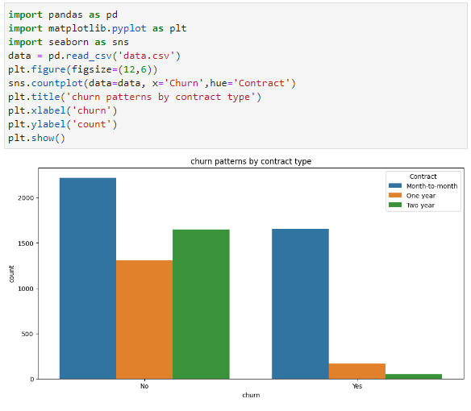
2. Retention Rate Analysis:
Visualizing retention rates over time can provide insights into how well you're retaining customers and where improvements might be needed.
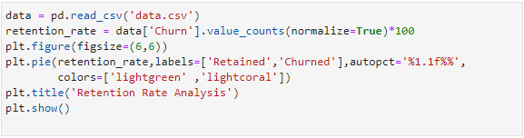
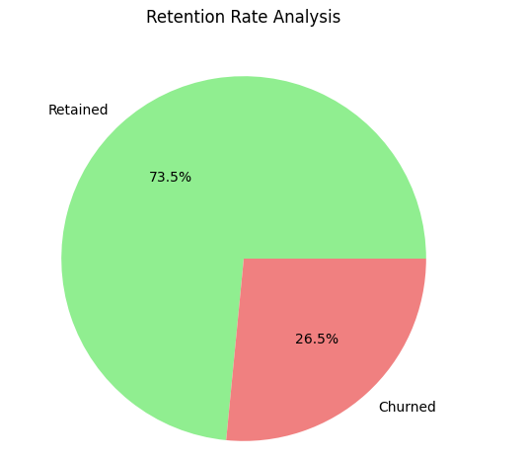
3. Key Factors Influencing Churn:
Using interactive dashboards and reports, you can explore and visualize the factors that most significantly influence customer churn. This might involve identifying correlations or trends in your data.
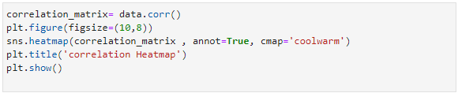
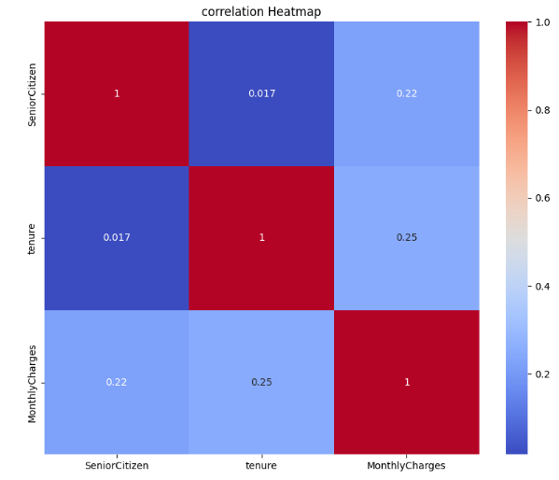
Developing a Predictive Model:
1. Data Preparation:
Ensure that your historical customer data is cleaned, preprocessed, and ready for analysis. This includes handling missing values, encoding categorical variables, and scaling features.
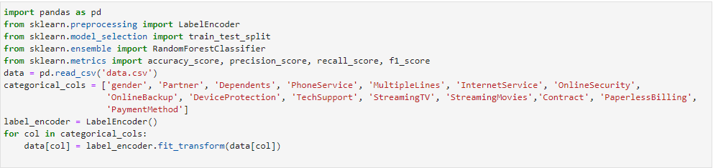
2. Visualizations in IBM Cognos:
Using IBM Cognos, create interactive dashboards and reports to visualize churn patterns, retention rates, and key factors influencing churn. You can use various visualization techniques like bar charts, line charts, pie charts, and heatmaps to present the data effectively.

3. Feature Selection:
Identify the most relevant features that influence customer churn. Visualizations can help you gain insights into which factors are most significant in predicting churn.

4. Machine Learning Model Development:
Choose appropriate machine learning algorithms for churn prediction. Common choices include logistic regression, decision trees, random forests, or gradient boosting. Train and evaluate these models using your historical data.

5. Model Evaluation:
Use metrics such as accuracy, precision, recall, and F1-score to assess the performance of your predictive model. Cross-validation and hyperparameter tuning can help improve model accuracy.
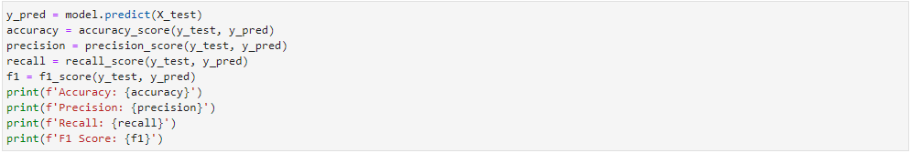

6. Deployment:
Once you have a well-performing predictive model, deploy it in your business environment to continuously monitor customer churn.

7. Feedback Loop:
Establish a feedback loop to update the model with new data and monitor its performance over time. This ensures that your model remains accurate as customer behavior evolves.

